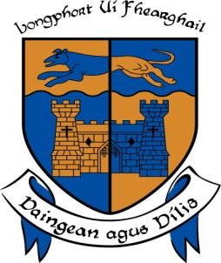

LONGFORD COUNTY COUNCIL

COMHAIRLE CHONTAE AN LONGFOIRT

Minutes of June Monthly Meeting of Longford County Council
held in the Council Chamber, Aras an Chontae, Great Water Street, Longford on
Wednesday, 8th June 2016 at 4.00 p.m.
____________________________________________________________________

PRESIDING: Councillor Gerry Warnock, Cathaoirleach.

MEMBERS PRESENT: Councillors – Paraic Brady, John Browne,
Seamus Butler, Mick Cahill, Micheál Carrigy, Mark Casey John Duffy, Gerard Farrell, Padraig Loughrey, Luie McEntire, Martin Mulleady, Colm Murray, Peggy Nolan, Pat O’Toole, P.J. Reilly, Paul Ross and Mae Sexton.

IN ATTENDANCE: Mr. John Brannigan, Director of Services.
Mr. John McKeon, Head of Finance.
Mr. Ciaran Murphy, Acting Director of Services.

APOLOGY: Ms. Barbara Heslin, Acting Chief Executive.

MEETINGS
ADMINISTRATOR: Ms. Anne Lee.

VOTE OF SYMPATHY.

On the proposal of Councillor G. Warnock seconded by Councillor S. Butler, it was unanimously resolved that a vote of sympathy be extended to Councillor Mick Cahill on the death of his Father, Mike, and that the meeting be adjourned as a mark of respect.

All members of the Council associated themselves with the vote of sympathy and many tributes were paid to Mike.

Mr. J. Brannigan, Director of Services, on his own behalf and on behalf of the staff of the County Council associated himself with the vote of sympathy.

It was agreed that the adjourned meeting be held on Wednesday, 15th June at 4.00 p.m.

Councillor Cahill thanked the Cathaoirleach, members and staff for their support and kind words.

A silent prayer was said for Mike.

This concluded the business of the meeting.
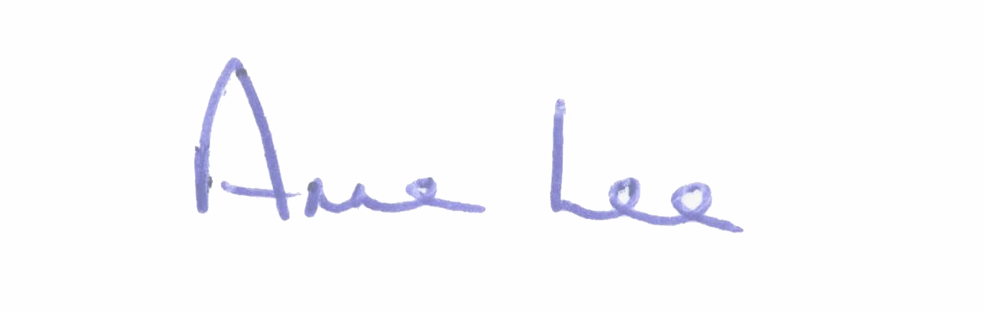

Signed: _______________
Anne Lee,
Meetings Administrator.

Confirmed and adopted at Monthly Meeting of Longford County Council held on
the 13th July 2016.

Signed: _______________
Cathaoirleach.

